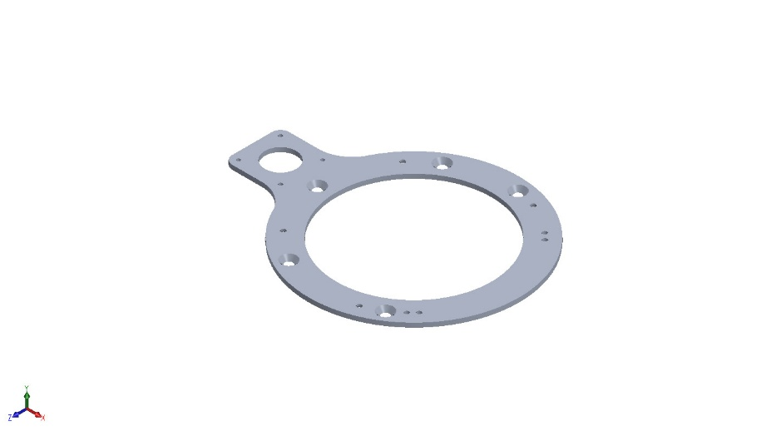
  Simulation of GEMINI-01-01-01
  Date: Thursday, January 8, 2026
  Designer: Solidworks
  Study name: Static 1
  Analysis type: Static
  Table of Contents
  Description 1
  Assumptions 2
  Model Information 2
  Study Properties 3
  Units 3
  Material Properties 4
  Loads and Fixtures 4
  Connector Definitions 5
  Interaction Information 5
  Mesh information 6
  Sensor Details 7
  Resultant Forces 8
  Beams 8
  Study Results 9
  Conclusion 12

Description
No Data

Assumptions

Model Information

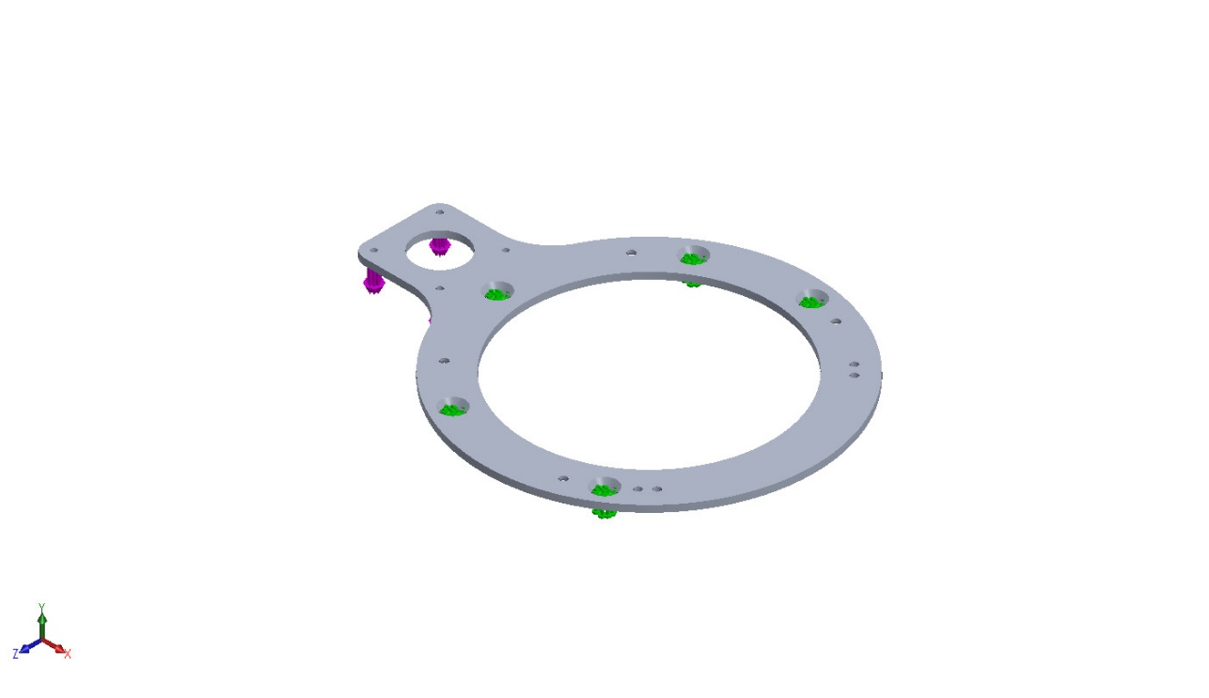
Model name: GEMINI-01-01-01
Current Configuration: Default
Solid Bodies
Document Name and Reference | Treated As | Volumetric Properties | Document Path/Date Modified
Split Line1  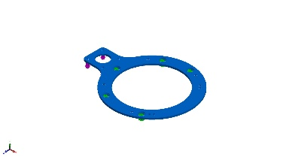 | Solid Body | Mass:0.082941 kg  Volume:3.07189e-05 m^3  Density:2,700 kg/m^3  Weight:0.812822 N | C:\Users\williamli\Desktop\GEMINI\CAD\GEMINI-01-01-01.SLDPRT  Jan 8 11:35:21 2026

Study Properties
Study name | Static 1
Analysis type | Static
Mesh type | Solid Mesh
Thermal Effect: | On
Thermal option | Include temperature loads
Zero strain temperature | 298 Kelvin
Include fluid pressure effects from SOLIDWORKS Flow Simulation | Off
Solver type | Automatic
Inplane Effect: | Off
Soft Spring: | Off
Inertial Relief: | Off
Incompatible bonding options | Automatic
Contact penalty stiffness scale factor | 1
Large displacement | Off
Compute free body forces | On
Friction | Off
Use Adaptive Method: | Off
Result folder | SOLIDWORKS document (C:\Users\williamli\Desktop\GEMINI\CAD)

Units
Unit system: | SI (MKS)
Length/Displacement | mm
Temperature | Kelvin
Angular velocity | Rad/sec
Pressure/Stress | N/m^2

Material Properties
Model Reference | Properties | Components
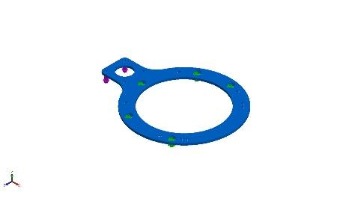 |  | SolidBody 1(#31 (Split Line1)(GEMINI-01-01-01)
  Name: | 6061-T6 (SS)
  Model type: | Linear Elastic Isotropic
  Default failure criterion: | Max von Mises Stress
  Yield strength: | 2.75e+08 N/m^2
  Tensile strength: | 3.1e+08 N/m^2
  Elastic modulus: | 6.9e+10 N/m^2
  Poisson's ratio: | 0.33
  Mass density: | 2,700 kg/m^3
  Shear modulus: | 2.6e+10 N/m^2
  Thermal expansion coefficient: | 2.4e-05 /Kelvin
Curve Data:N/A

Loads and Fixtures
Fixture name | Fixture Image | Fixture Details
Fixed-1 | 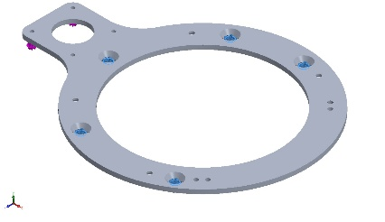
  Entities: | 5 edge(s)
  Type: | Fixed Geometry
Resultant Forces
Components | X | Y | Z | Resultant
Reaction force(N) | 8.34465e-07 | 0.962499 | -8.49366e-07 | 0.962499
Reaction Moment(N.m) | 0 | 0 | 0 | 0

Load name | Load Image | Load Details
Force-1 | 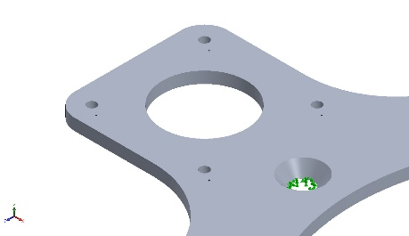
  Entities: | 4 face(s)
  Type: | Apply normal force
  Value: | -0.9625 N

Connector Definitions
No Data

Interaction Information
No Data

Mesh information
Mesh type | Solid Mesh
Mesher Used: | Blended curvature-based mesh
Jacobian points for High quality mesh | 16 Points
Maximum element size | 0.246688 in
Minimum element size | 0.0376657 in
Mesh Quality | High

Mesh information - Details
Total Nodes | 14668
Total Elements | 7500
Maximum Aspect Ratio | 6.7954
% of elements with Aspect Ratio < 3 | 98.4
Percentage of elements with Aspect Ratio > 10 | 0
Percentage of distorted elements | 0
Time to complete mesh(hh;mm;ss): | 00:00:03
Computer name: | WILLIAMLI2E83

Mesh Quality Plots
Name | Type | Min | Max
Quality1 | Mesh | - | -
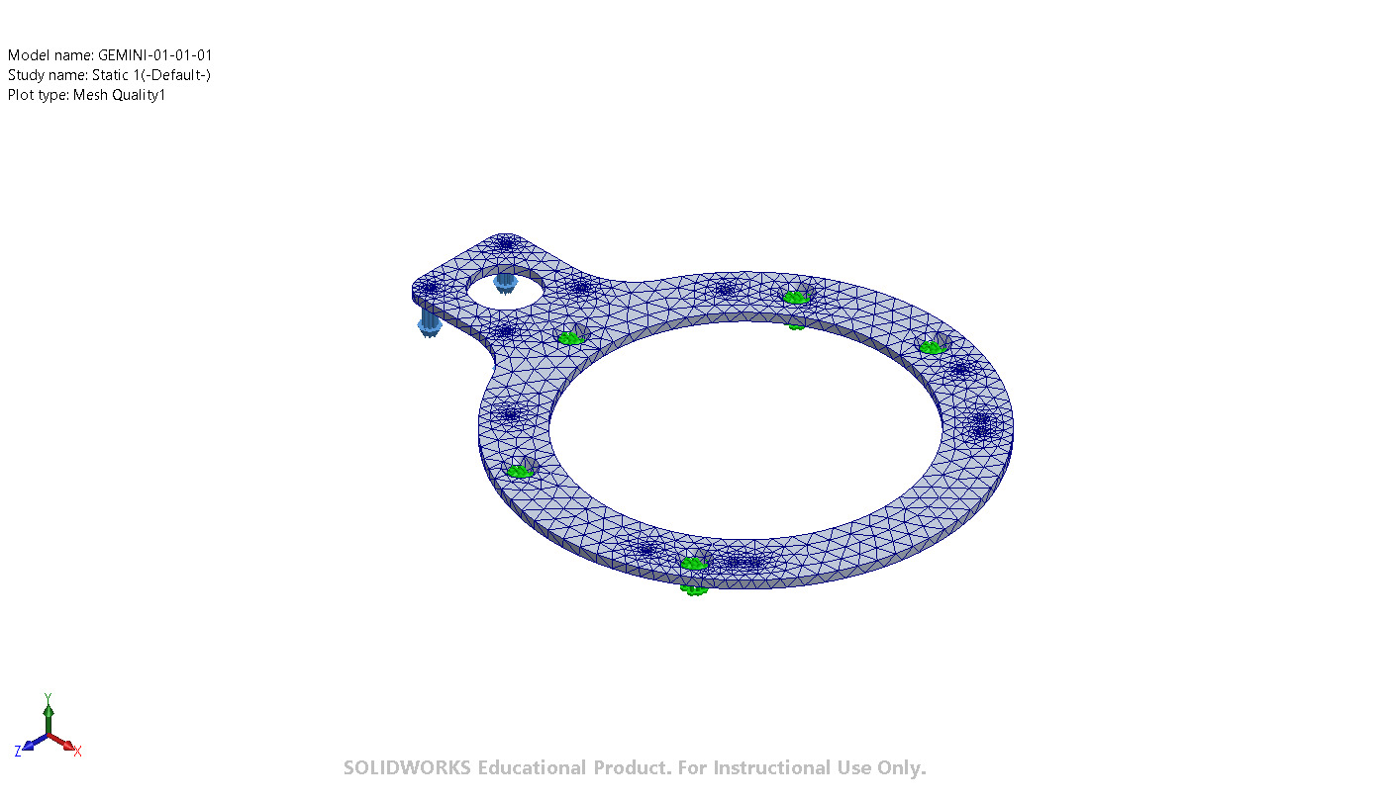
GEMINI-01-01-01-Static 1-Quality-Quality1

Sensor Details
No Data

Resultant Forces

Reaction forces
Selection set | Units | Sum X | Sum Y | Sum Z | Resultant
Entire Model | N | 8.34465e-07 | 0.962499 | -8.49366e-07 | 0.962499

Reaction Moments
Selection set | Units | Sum X | Sum Y | Sum Z | Resultant
Entire Model | N.m | 0 | 0 | 0 | 0

Free body forces
Selection set | Units | Sum X | Sum Y | Sum Z | Resultant
Entire Model | N | 8.6776e-07 | -1.04774e-07 | -8.49832e-07 | 1.2191e-06

Free body moments
Selection set | Units | Sum X | Sum Y | Sum Z | Resultant
Entire Model | N.m | 0 | 0 | 0 | 1e-33

Beams
No Data

Study Results

Name | Type | Min | Max
Stress1 | VON: von Mises Stress | 1.065e-05N/mm^2 (MPa)  Node: 2568 | 4.395e+00N/mm^2 (MPa)  Node: 419
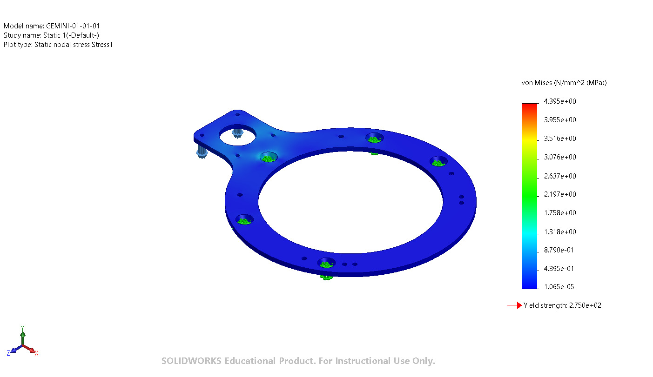
GEMINI-01-01-01-Static 1-Stress-Stress1

Name | Type | Min | Max
Displacement1 | URES: Resultant Displacement | 0.000e+00mil  Node: 35 | 3.445e-01mil  Node: 1058
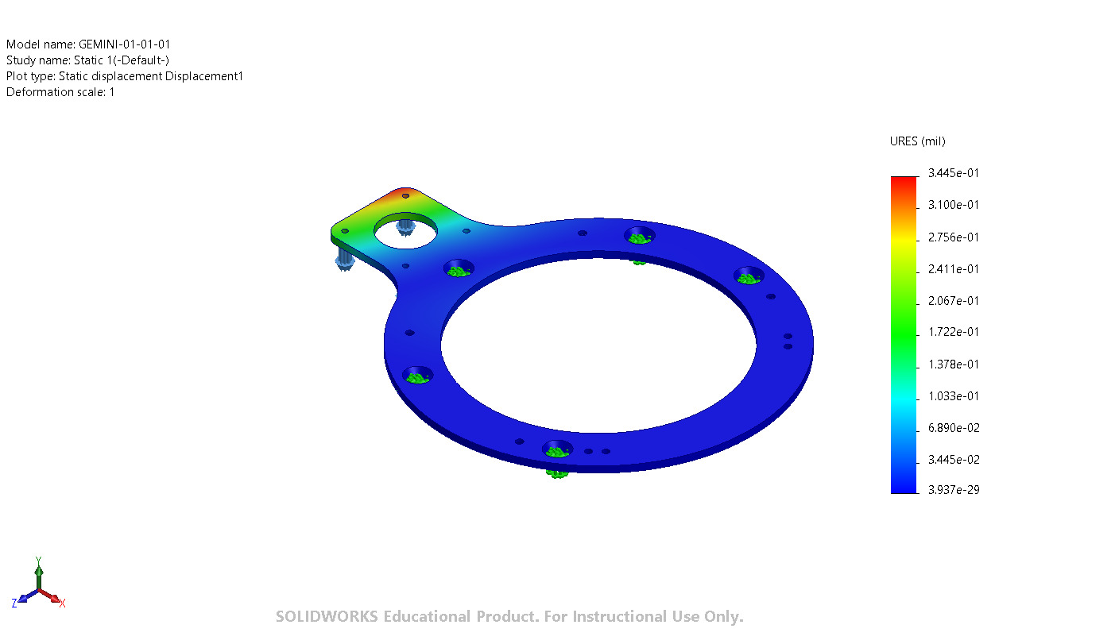
GEMINI-01-01-01-Static 1-Displacement-Displacement1

Name | Type | Min | Max
Strain1 | ESTRN: Equivalent Strain | 8.163e-11  Element: 5773 | 2.375e-05  Element: 3975
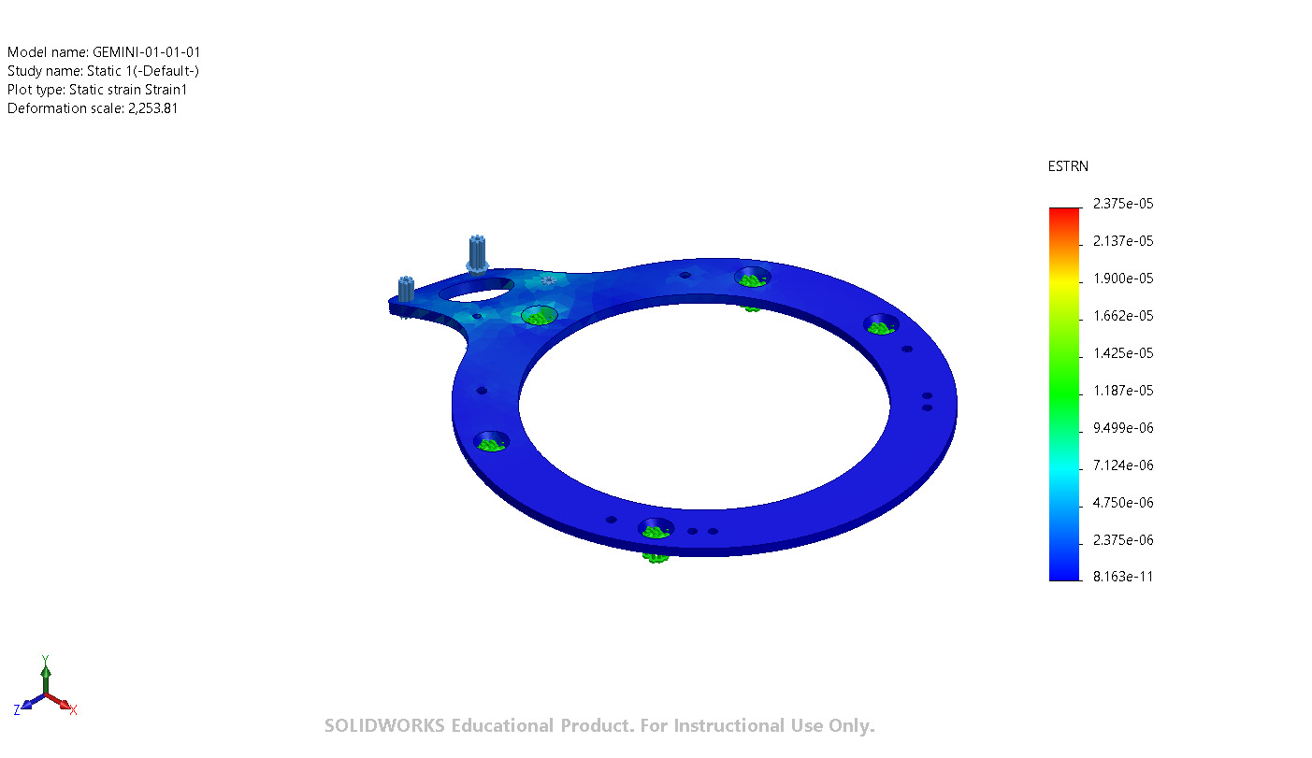
GEMINI-01-01-01-Static 1-Strain-Strain1

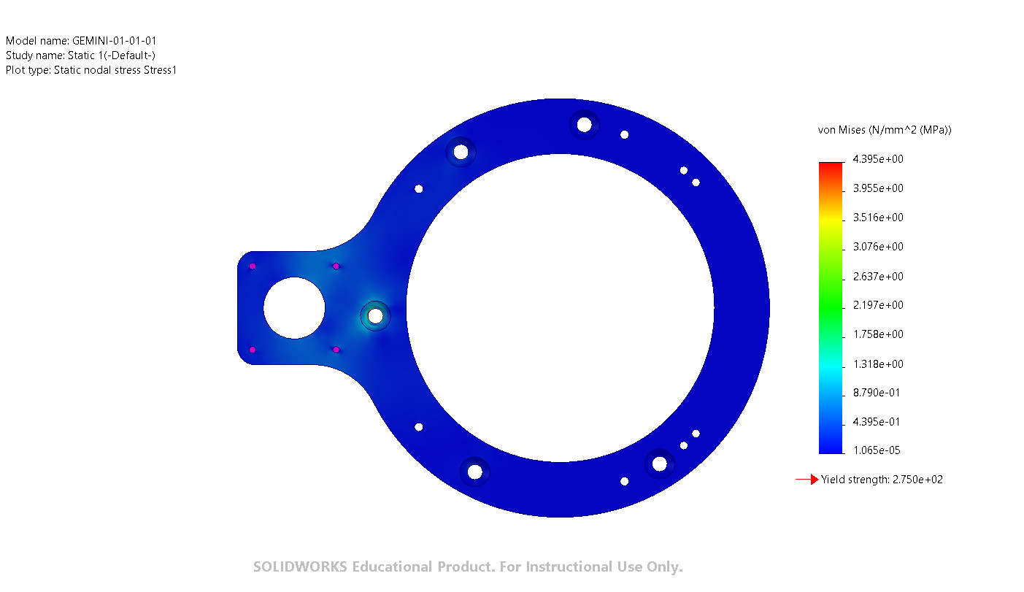
Image-1

Conclusion

